**GIT Department of Computer Engineering**

**CSE 222/505 - Spring 2021**

**Homework 1 Report**

**Student Name**

**Samet NALBANT**

**Student Number**

**1801042614**

1. **SYSTEM REQUIREMENTS**

1)Firstly company must be created.

2)Administrator must be set to use administrator functions. Branches, branch employees can create or remove using the administrator functions.

3)Branch Employees can add products, remove products and make sales to customers. Customers need to be subscribed company to buy something. If customer shopping first time branch employee can do subscription.

4)Customers search products, shop online, show products, and can view their previous orders. To be able to do all of these customers should subscribe to company. After the subscription they will informed about their customer ID.

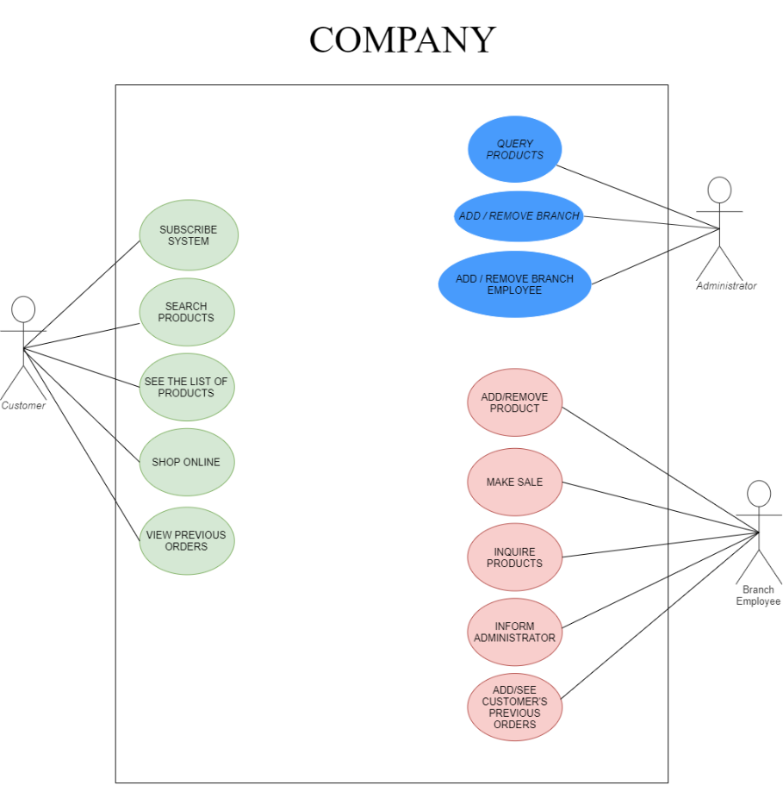**USE CASE DIAGRAM**

**UML CLASS DIAGRAM**

**CLASS DIAGRAM**

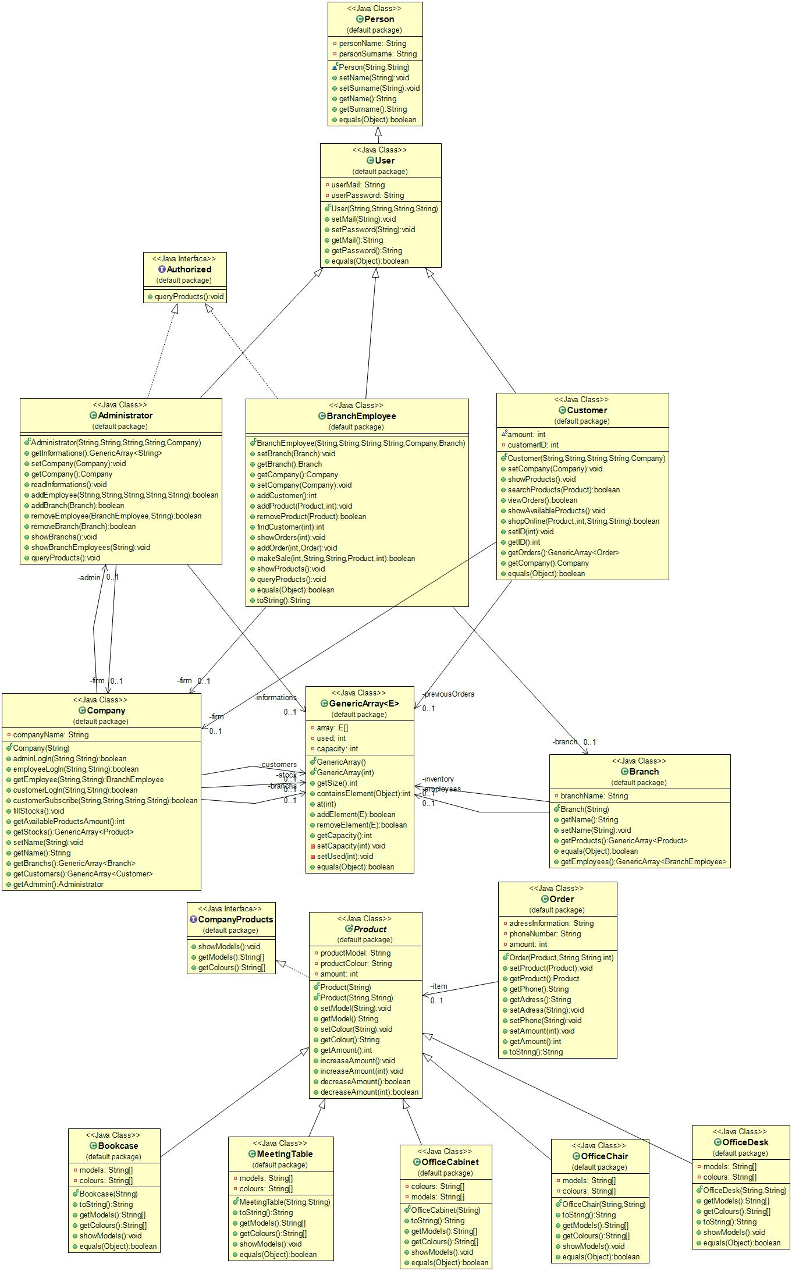

1. **PROBLEM SOLUTION APPROACH**

I list the necessary functions for automation system. Then I design cursory class hierarchy. After I realize that generic types will be so useful. So I create generic type array class based on java collection. I create product class and furniture classes (bookcase, office desk etc.) as a subclass of product class. I create product class as an abstract class because furniture classes almost have same functions and same implementation and also they have some differences. So I can use polymorphism easily. I implement an interface to product class, this way I can create functions which has different implementation. After the complete product part I create person class to keep people’s specific information such as name, surname etc. Then I create user class as a subclass of person to hold necessary information to use entering automation system. After I implement employee, administrator, customer subclasses of user with functions which defined in homework and other helper functions. After that I create company and branch classes appropriate way. Finally I need to order class to hold customer’s previous orders.

1. **TEST CASES**

To be able to test system I create company and administrator of the company. 

After that I use administrator functions for the automation system.

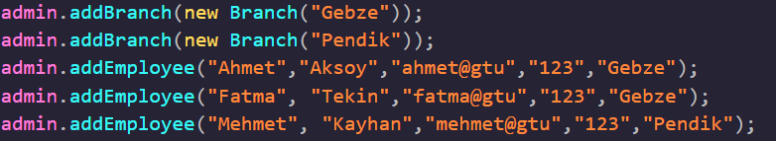

Automation system needs to some products. So using branch employee functions I add some products.

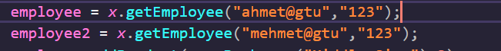

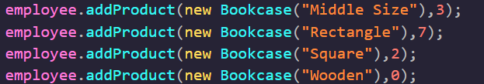

I didn’t add the all model of each product because using the automation system all models all colors can be add according to user’s requests.



I create two customer. To shop some products using their ID.





Finally I try to remove not existing branch to see the throw exception.





1. **RUNNING AND RESULTS**

Entering system as an administrator.

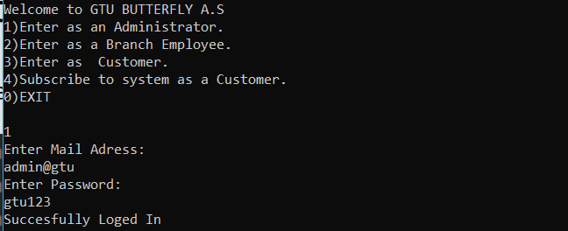

Trying to add new branch.

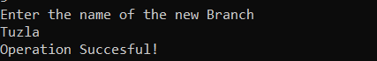

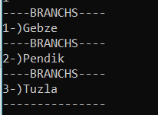

-Trying to add already exist branch.

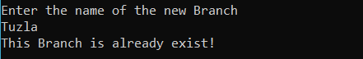

-Trying to remove branch.

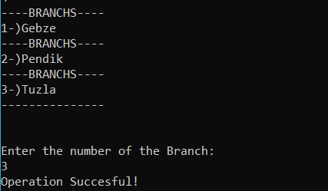

After remove:

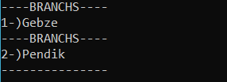

-Adding employee

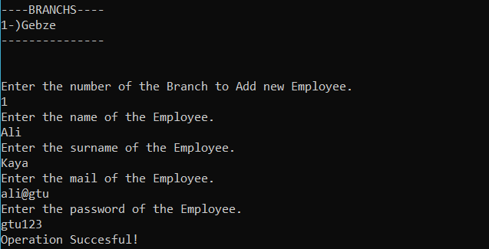

-Removing Employee

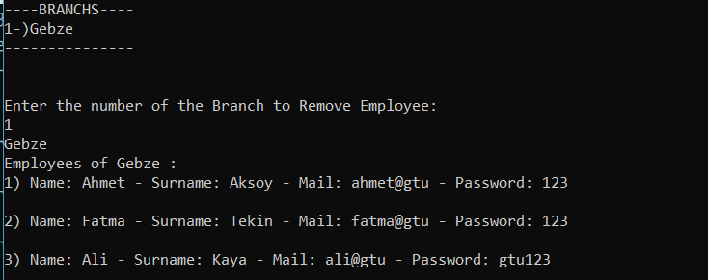

-Query Products

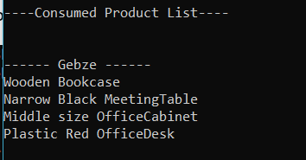

-Entering as a branch employee

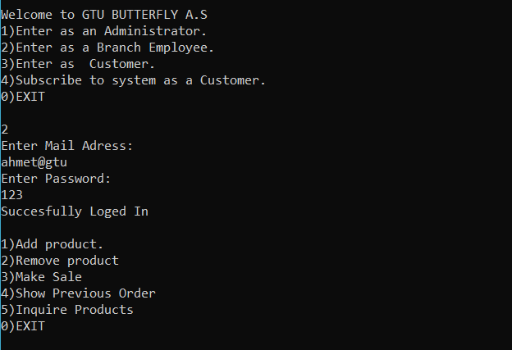

-Add product

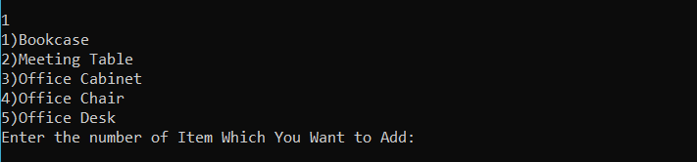

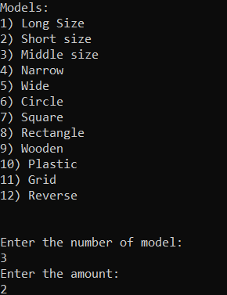

-Removing product.

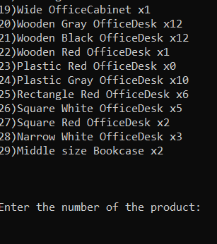

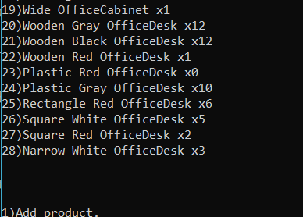

-Make sale

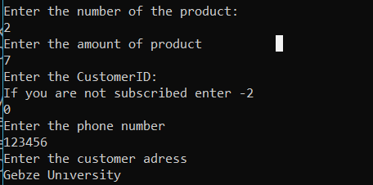



-Show preivous orders

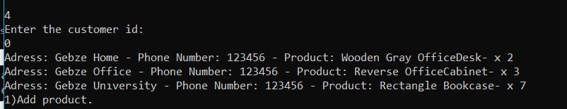

-Inquıre Products

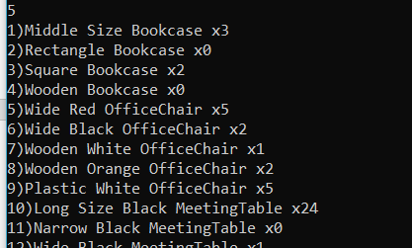

...

-Entering as a customer

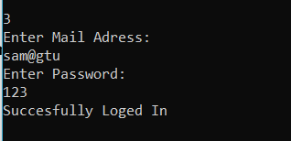

-See list of products show which stores has how many products.

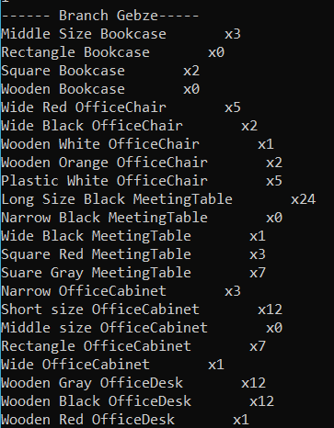

-Search products takes model and colour as an number again.And shows which branch has it.

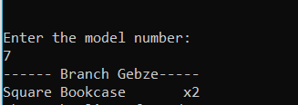

-Shop online shows the all products in branchs.

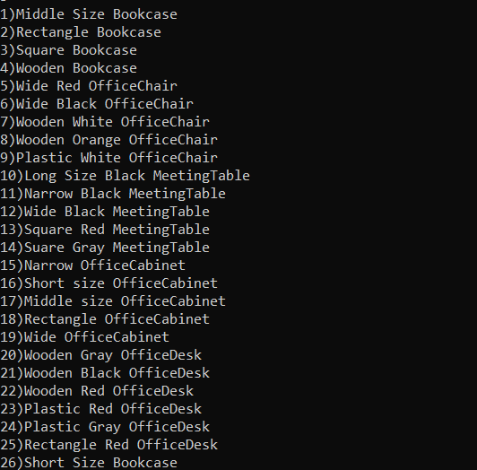

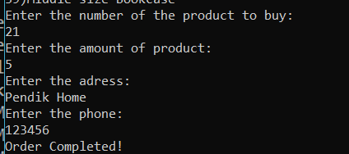

-View previous orders.

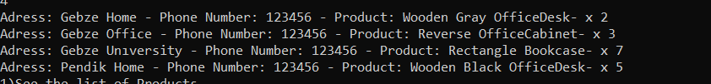

-Subscribe system as a customer

